Clint Hawkes
cs340 - 400
Assignment 4

1.
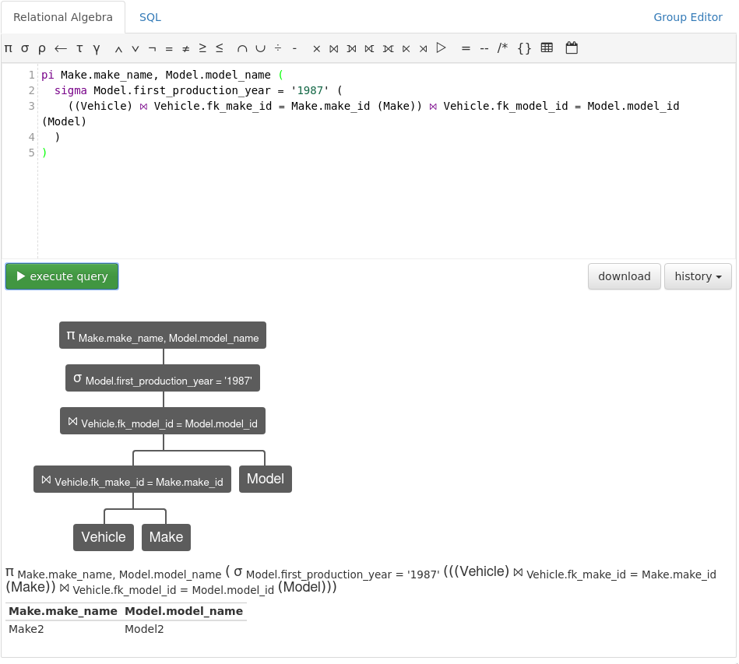

2.
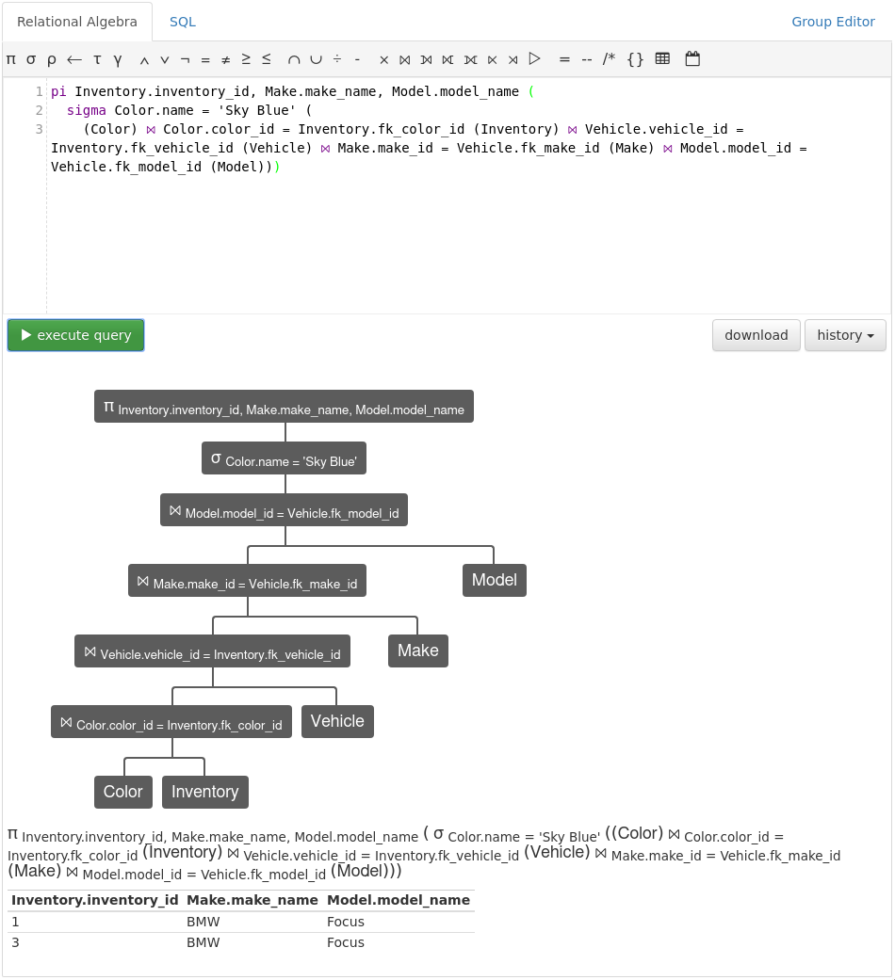
The rubric instructed us to include the ID, so that caused the resulting table to have 2 rows rather than the 1 row if the ID was left out.

3.
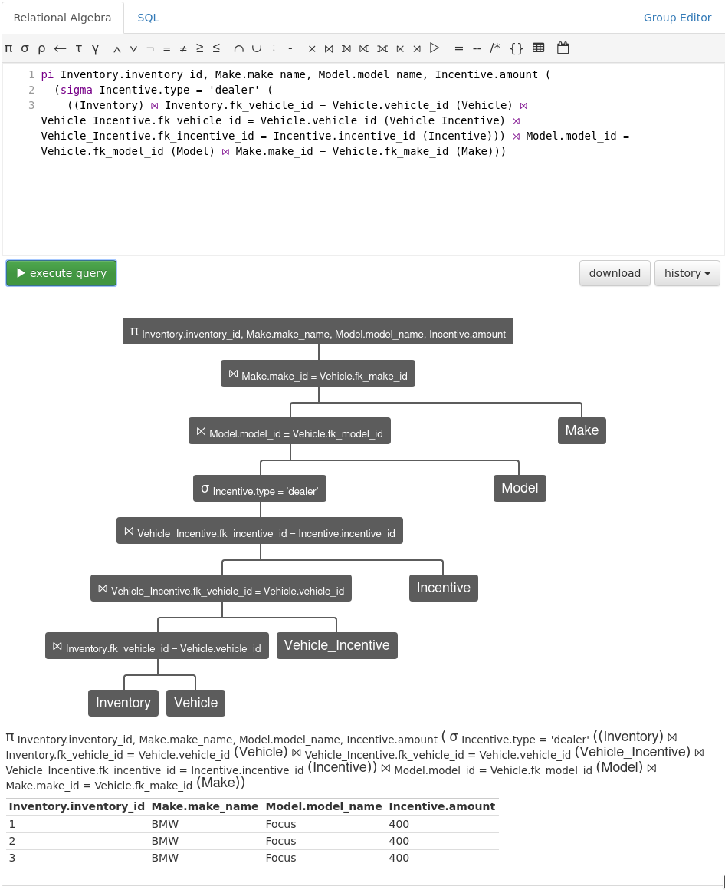
The rubric instructed us to include the ID, so that caused the resulting table to have 3 rows rather than the 1 row if the ID was left out.

4.
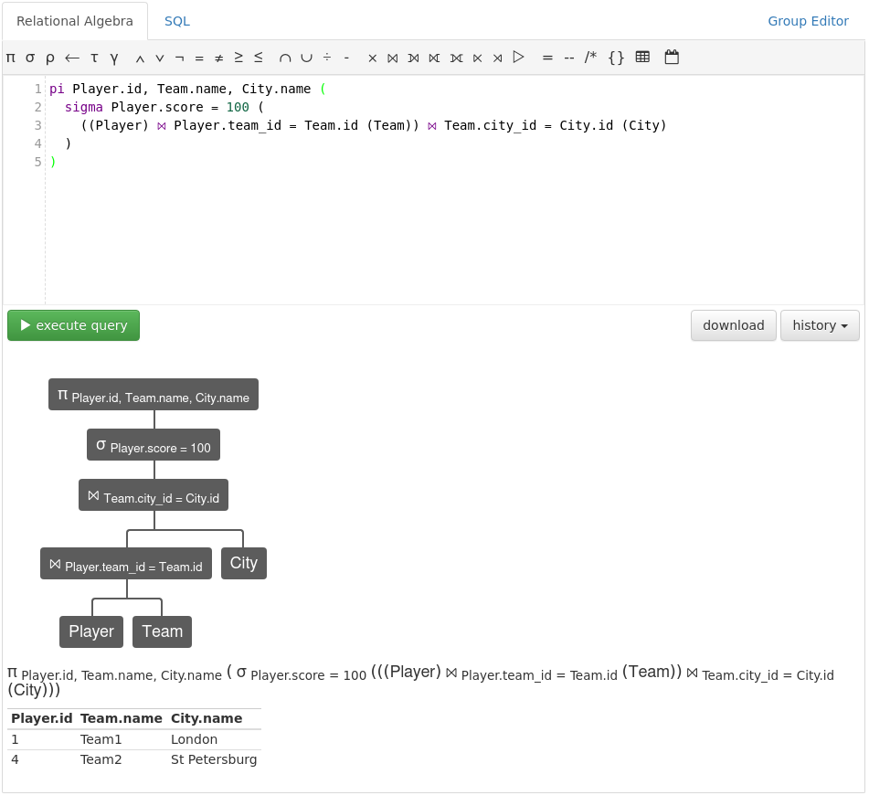

5.
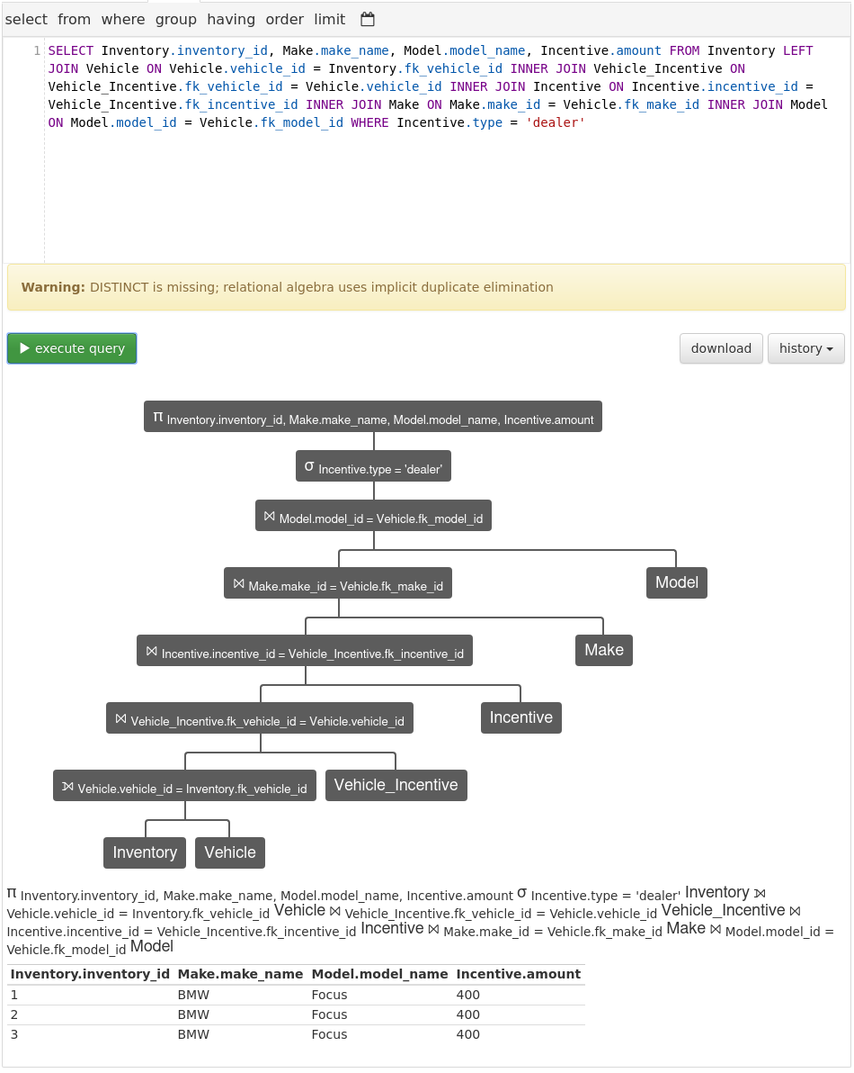
Once again, the rubric instructed us to include the ID, so that caused the resulting table to have 3 rows rather than the 1 row if the ID was left out.

